**Assignment Part-3**

1. **Create a file like nano file1.txt o Edit some data and then save the file.**

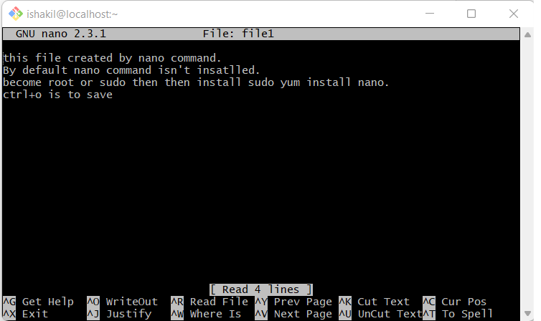

Nano is editor like vi/vim .

By default, nano command isn't installed.

become root or sudo then then install sudo yum install nano.

ctrl+o is to save, ctrl +x to exit.

**2. Now we will copy date from file1 to new file2**

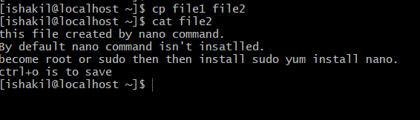

-cp command is used to copy content/file from 1 file to other. Whenever cp is used, another new file will be created if file does not exist.

-cat command is used for various purpose. I have used to display the content inside the file1/file

**3.Now we will move the file2.txt to new folder /home**

* + mv file2.txt /home
  + Then go to home directory and check ls, file exits or not?

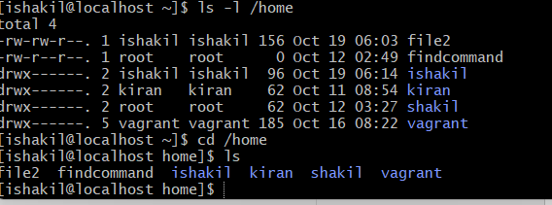

* We can check if file exist or not, using ls -l /home if we are in another directory.
* Also, I change the directory, cd /home and list the file using “ ls”.

**4. Then we create a new file3.txt and file4.txt in home directory and add content in it.**

o Now do echo “Hello I am newline” > file3.txt and provide the output of file3.txt

o Now do echo “Hello I am newline” >> file4.txt and provide the output of file4.txt

o Tell the different between both step you follow and the reason behind it

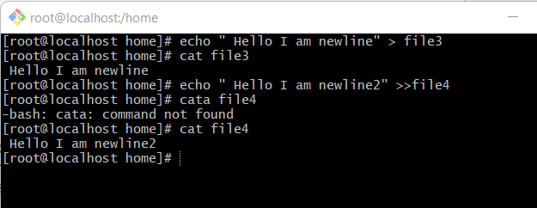

* the “>” is the output redirection operator used for overwriting files that already exist in the directory. While, the “>>” is an output operator as well, but, it appends the data of an existing file. Often, both of these operators are used together to modify files in Linux.

**5. For remove a file or directory you can use the below two commands**

* To delete a file – rm filename
* To delete a directory - rm dir < any _ directoryname
* As you can see file4 and directory testdir is not there anymore

